Softuniada 2019

Elemelons
If there is a watermelon, then there should be earthmelon, firemelon and airmelon. Introducing, the Elemelons! Doctor Sanity has a very unusual 3-D garden with elemenlons. The elemelons like to morph into each other when they are not observed, and Doc doesn’t like that. He has called for your help in implementing an algorithm which helps him observe his surroundings while reaping elemelons so that they don’t change.
You will be given N – the dimensions of the 3-D matrix – the garden of Doctor Sanity, and the matrix itself afterwards, in a series of N rows containing the columns of N matrices – the layers of the 3-D matrix. The matrix will consist of the following symbols: W (Watermelon), E (Earthmelon), F (Firemelon), A (Airmelon).
For an example, let’s color W (blue), E (orange), F (red) A (gray-white)
Check the examples below, for more info:
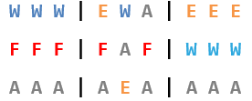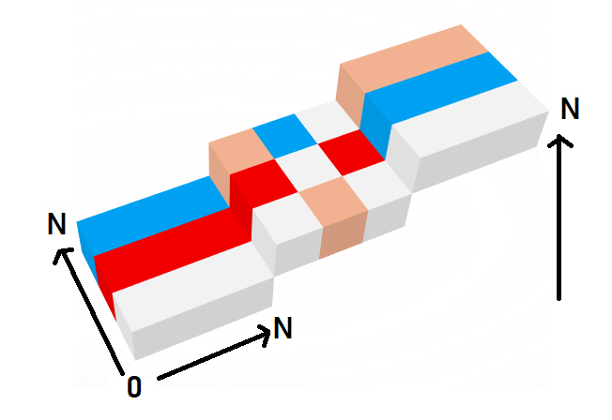
After you’ve successfully initialized the 3-D matrix, you’ll start receiving coordinates – the cell that Doctor Sanity will harvest a melon from. Upon harvesting a melon, that cell in the 3-D matrix should be set to '0'. All other melons, except the ones in direct sight of Doc (up, down, left, right, front, back from the currently harvested cell), should morph.
The morphing order is: Watermelon (W) -> Earthmelon (E) -> Firemelon (F) -> Airmelon (A) -> Watermelon (W)… and so on.
Upon receiving the command "Melolemonmelon", the input sequence should end, and you should print the current state of the 3-D matrix in the same format, that you’ve received it from the input. Then you should end the program.

Input
The input consists of several lines:
- On the first line you will receive an integer number N – the size of the 3-D matrix.
- At the next N lines the layers of the 3-D matrix are given (from bottom to top) as a sequence of N matrices separated by " | ".
- Afterwards, you will start receiving coordinates of a cell in the following format:
"{layer} {row} {column}"
- When you receive the command "Melolemonmelon" the input sequence should end.

Output
As output you must print the current state of the 3-D matrix, in the same format as it came from the input – rows, containing the columns of N matrices – the layers of the cube (from bottom to top).

Constraints
- The integer N will be in range [0, 50].
- The 3-D matrix will always be in a valid format and will only contain the following characters: 'W', 'E', 'F', 'A'.
- The coordinates for the cell to be harvested, will always be inside the 3-D matrix.
- Allowed time / memory: 100ms / 16MB.

Examples
Input | Output | Comment
3  W W W | E W A | E E E  F F F | F A F | W W W  A A A | A E A | A A A  1 1 1  Melolemonmelon | E E E | F W W | F F F  A F A | F 0 F | E W E  W W W | W E W | W W W | The cell at layer 1, row 1, column 1 was changed to '0', as it was harvested.  The yellow marked cells were in direct sight of Doctor Sanity, which is why the melons inside them didn’t morph.  All other cells’ melons morphed into the next melon in order.

Input | Output
4  A W F A | W W W W | W W W W | A A A A  W F W F | F F F F | A A A A | F F F F  A W E W | E E E E | A A A A | W E E W  A F W E | W W W W | W W W W | W W W W  1 1 1  2 3 2  3 1 3  Melolemonmelon | F A E F | A F A A | A A A A | F F F E  A W A E | W 0 W E | F E F E | E E W 0  F A W A | W A W W | F F E F | A W W F  F E A W | A A F A | A F 0 F | A A F A

